**always Check a translation is worth it?**

HOW OFTEN CAN WE CHECK TRANSLATION?

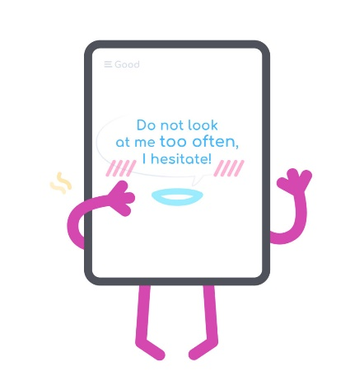

Try to translate on your own before getting a peek to automatic translation. The EasyLang provides the possibility to hide the translation. And also Tooltips with a dictionary can view definitions from dictionaries.

That means it shows English vocabulary entries for a word. Therefore, you can take highly productive learning path.

**Summary of Online Translators**

Google Translate – on the fly improving service. After the translation completed, the resulting translation can be corrected. Correction is executed with the simple move of a mouse.

Microsoft Translator – getting pretty good with technical articles.

Promt Online  - one of the original translate program market

Yahoo Translate – request for beforehand correct articles, i.e. can’t propose some corrections, as Google Translate does.